Import Facebook Dataset

betweenness Centrality

Degree Centrality

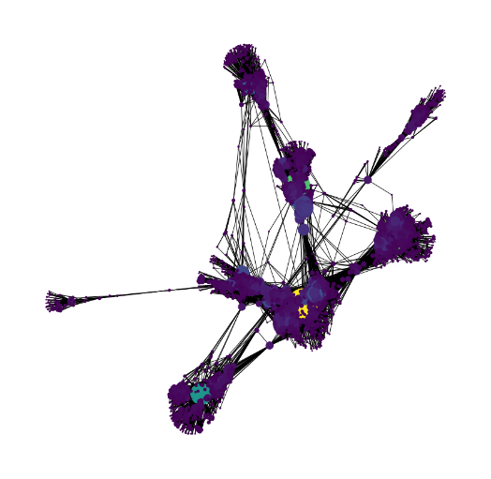

Sorted

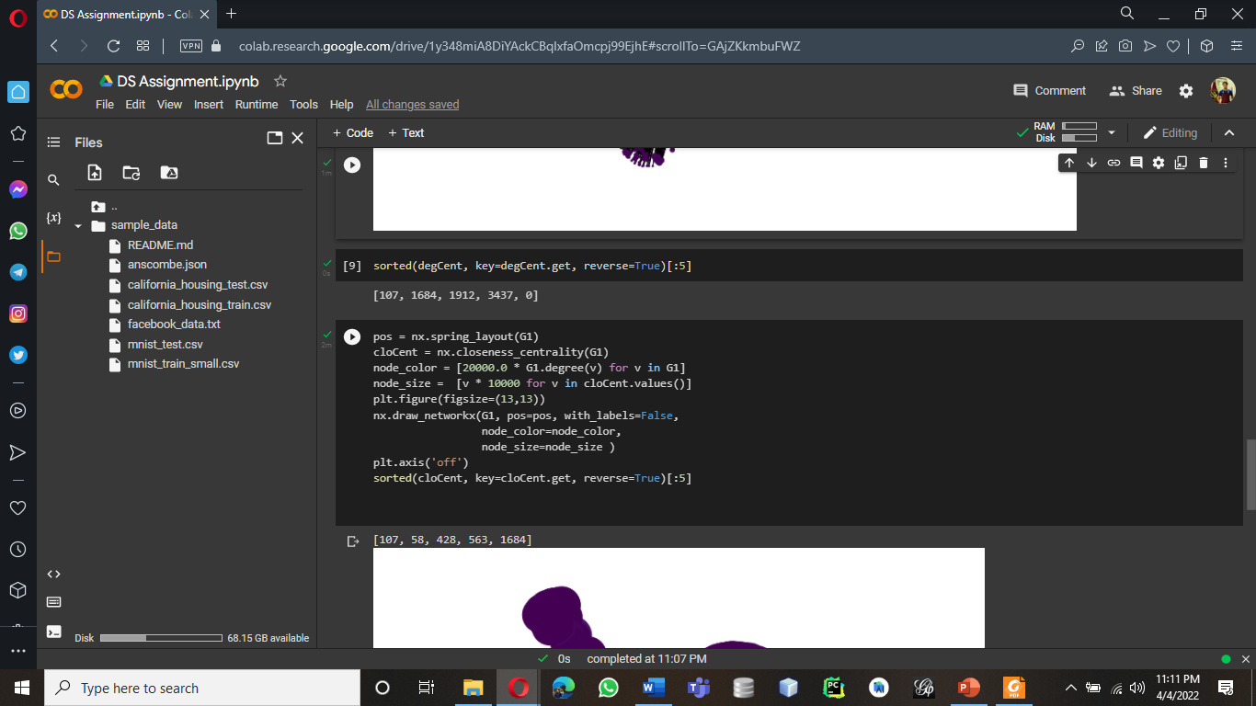

Closeness Centrality

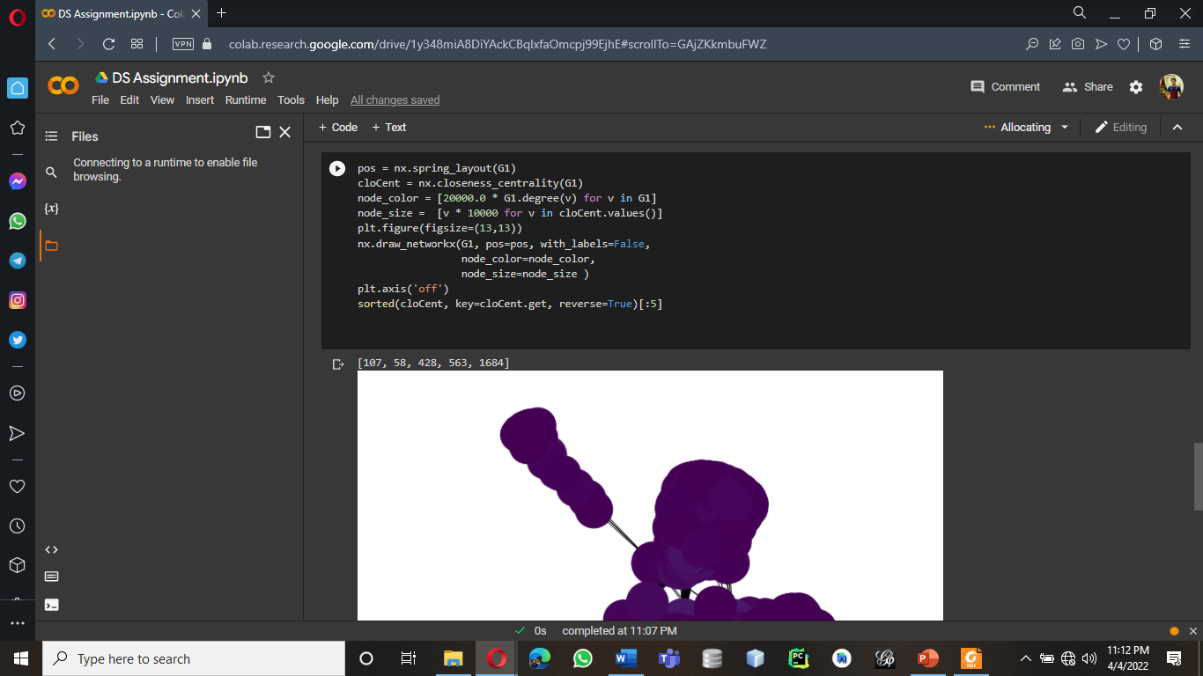

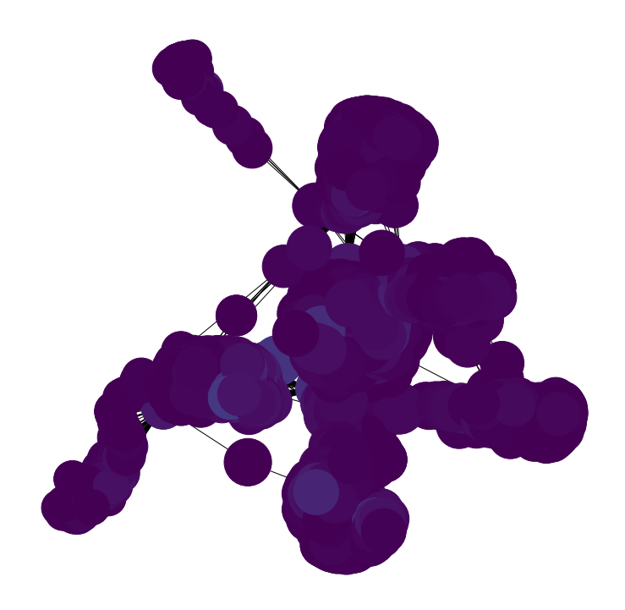

Degree Graph

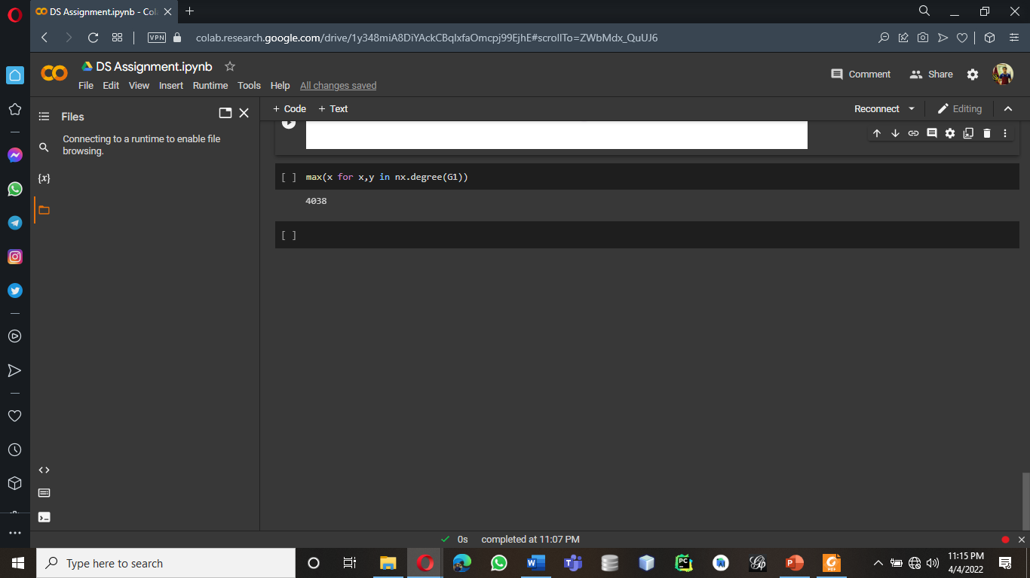

Clustering for 5 different Nodes

Average Clustering

Eccentricity

Data Set

